THE MEN’S SHED EXTENSION.

Project
The Hartlepool NDC Trust were recently commissioned to build an extension on to the back of the Oz Centre, occupied by the Hartlepool Men’s Shed; a local community organisation established in March 2016.
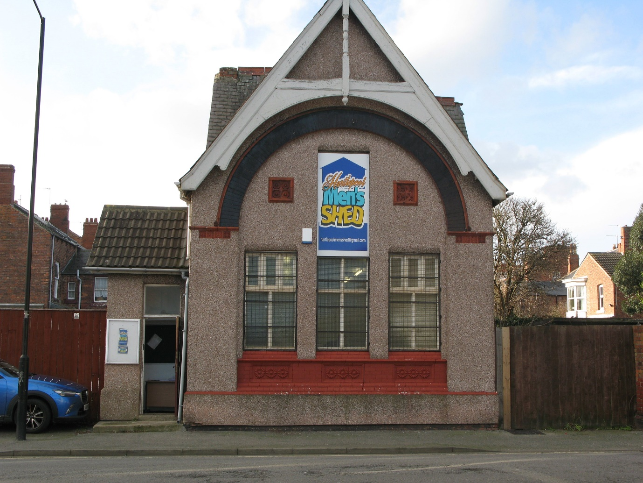

Background
The Hartlepool NDC Trust owns the Oz centre, a former church hall building that has had various uses over the years.
The Hartlepool NDC Trust – Is a small local charity that delivers construction and employability training to those who are furthest from the labour market, including long-term unemployed, people recovering from addictions or mental health issues and students who need on-site experience.
The Hartlepool Men’s Shed became the latest tenants soon after they were established.
The Hartlepool Men’s Shed - So, what is a Men's Shed? The answer may appear obvious - a place for males to make and mend things, a larger version of your typical garden shed! Well, that`s true, but they are much more than that. They are equally about reducing isolation, helping people to make friends and improving health and well-being. Sheds are fine places to share a problem - hence the suggestion men prefer to talk 'shoulder to shoulder'.
Membership of the Hartlepool Men’s Shed grew very rapidly which prompted them to think about extending the building to create more workshop space and they commissioned the Hartlepool NDC Trust to build the extension.
As part of the building project, the NDC Trust promised to use students from the Hartlepool College of Further Education and in so doing, provide them with valuable on-site experience which would count towards their qualifications.

The Extension Works.
The NDC Trust commissioned a local builder, Smurthwaite and Duncan, to dig the foundations and build the extension up to damp course level. This was because the bricklaying students at the College were unable to carry out this work. Whilst digging the foundations, the builders came across an issue with the drainage for the building in that there was piping that was not contained on the plans. An extra drainage solution had to be built to satisfy the building control officer.
Whilst this work was being carried out, 20 construction year 1, level 3 technical and professional students were able to get on site and access the plans and drawings in order to carry out an exercise in assessing and estimating the materials needed for the project, along with associated costs. The issue with the drainage gave them and added problem to solve.
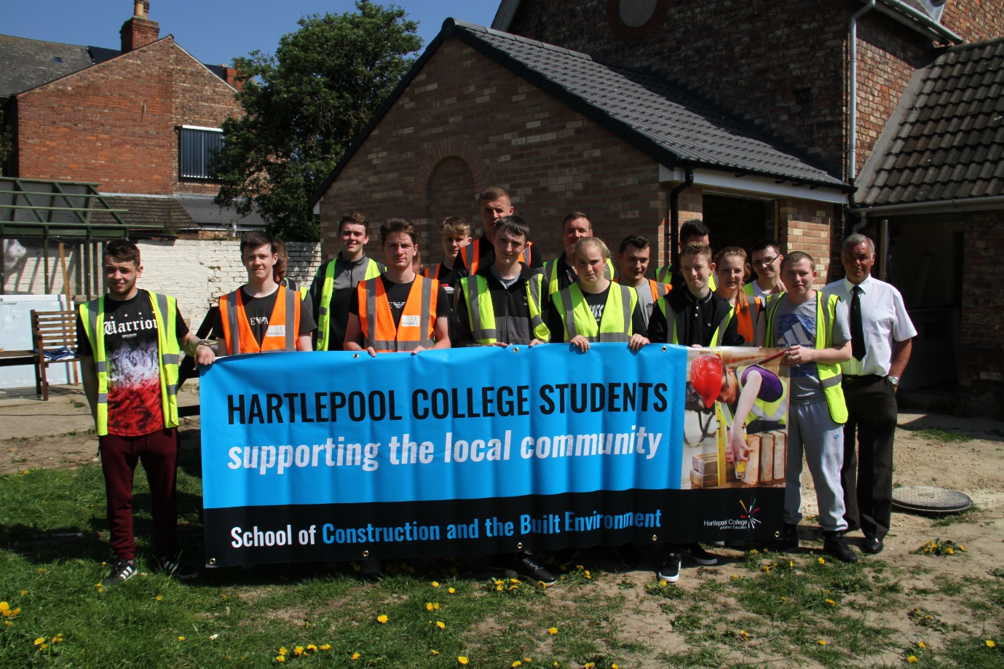
The College of Further Education donated 1,500 bricks to the project which helped reduce the overall cost of the extension
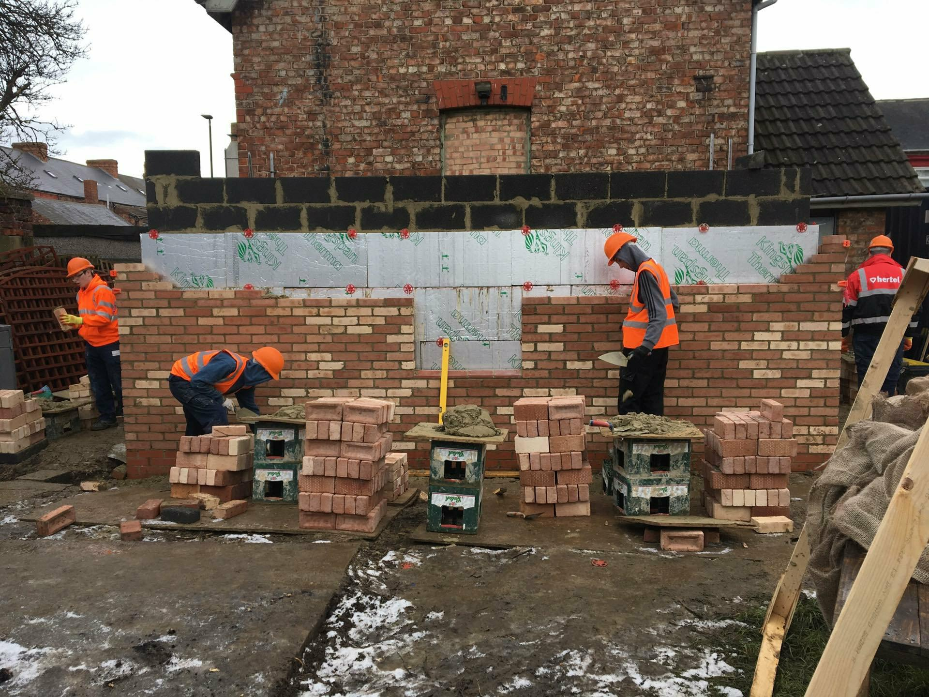

A total of 32 bricklaying students, under the supervision of College lecturers, Andy Hetherington and Bob Gardner, worked on the project at different times. These were made up from a mixture of full-time year 2 and year 3 students and a number of apprentices. Issues with bad weather meant that the building work took a bit longer than hoped but the quality of workmanship has been really impressive.
The NDC Trust employs an apprentice joiner who is also studying at the Hartlepool College of FE. Once the walls had been built, it gave the joinery apprentice an opportunity to fit his first roof. He also gained valuable experience in fitting the fire doors, fascias and boarded out the interior walls.
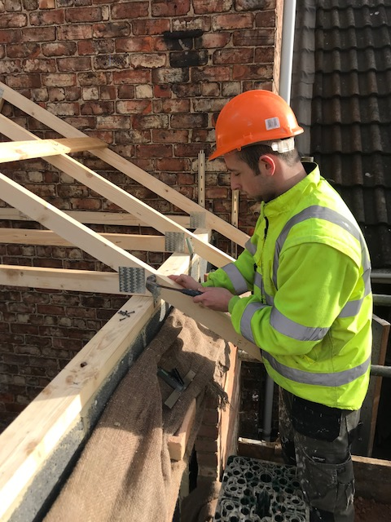
The NDC Trust then used 6 of their own trainees to decorate the inside of the extension. All of the trainees were long-term unemployed and volunteering with the NDC Trust, learning new skills and gaining experience as they search for employment.

Outcomes.
In total, 53 construction students from the Hartlepool College of Further Education and 6 NDC Trust trainees have worked on the extension to the Men’s Shed. The students were from all age groups and all abilities and each of them gained some excellent experience working on a real-life project.
Over the course of the project, 5 contractors were brought in to carry out specialist work. All of these were Hartlepool-based companies. 8 Hartlepool companies were also used to supply materials to the project, including MKM Building supplies, which kindly donated some of the materials.
John Cartwright, Head of School- Construction and the Built Environment at Hartlepool College of FE, said,
“The Men’s shed project was a well-received community project constructed by students and staff from Hartlepool College and using bricks donated by Hartlepool college.
The college utilised this work experience to enhance and enrich a variety of different learners and enabled them to see a project competed from start to finish.
The job was an excellent way to stretch and challenge learners on different levels and different stages of their courses in the department of construction and the built environment.
In total we had 20 construction year 1, level 3 technical and professional learners who viewed the project from the start and worked with the drawings and specifications to determine the amount of material needed for the project.
This real scenario is priceless in the development of their skills and knowledge and by using a real project added value to their understanding of how maths and English are embedded in construction.

We also had a total of 32 bricklaying students work on the project at different stages. Some of these learners are apprentices but 12 of them are on full time level 2 and level 3 courses at the college.
This type of work is essential in the skills development of full time learners, to understand the different techniques used in industry, to work in a variety of climatic elements and work in real working conditions is something that they will never forget.
By reading and understanding the drawings, working from scaffold, mixing mortar and building a structure that is going to stay in place for years to come is a proud moment for them.

Overall the constructed building was a huge success and the standard of work was excellent.”

Peter Gowland, a Committee member of the Hartlepool Men’s Shed said;
“The Men’s Shed was delighted to work in partnership with the NDC Trust and the College of Further Education, in particular the students, who did a magnificent job in helping to construct the extension. The work was first rate from the students and indeed the staff. They co-operated excellently with the men from the Shed and we look forward to the young people becoming users of the Shed in the future if they so wish.

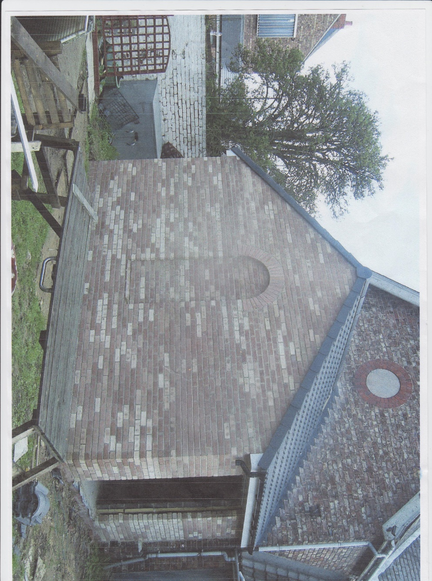

Summary.
The construction of the extension gave 59 young people an opportunity to grow their skills and gain valuable experience on their path towards the world of work.
13 Hartlepool-based businesses benefitted from this project through funding, acquired by the Men’s shed, from sources outside of Hartlepool.
Everyone involved contributed to the community by improving an important building in a conservation area and providing a much-improved community space and capacity for a popular local organisation.

